**TAMSAT-ALERT Soil Moisture Forecast for Kitui MAM 2020**

**Date issued:** 18th March 2020

**Meteorological tercile forecast:** B0.30, N0.35, A0.35 (GHACOF 54)

**Soil moisture tercile forecast:** B0.01, N0.06, A0.93

* At this early stage in the season, the MAM forecast for Kitui County is for above average (enhanced) soil moisture conditions.
* The soil moisture forecast reflects 1) the GHACOF 54 statement forecasting slightly above normal rainfall conditions for the MAM season, and 2) the current state of the land surface, which remains wetter than usual after heavy OND rains and continuing rainfall throughout the short dry season.
* Since the previous forecast was issued, the onset of the rains has elevated soil moisture.
* 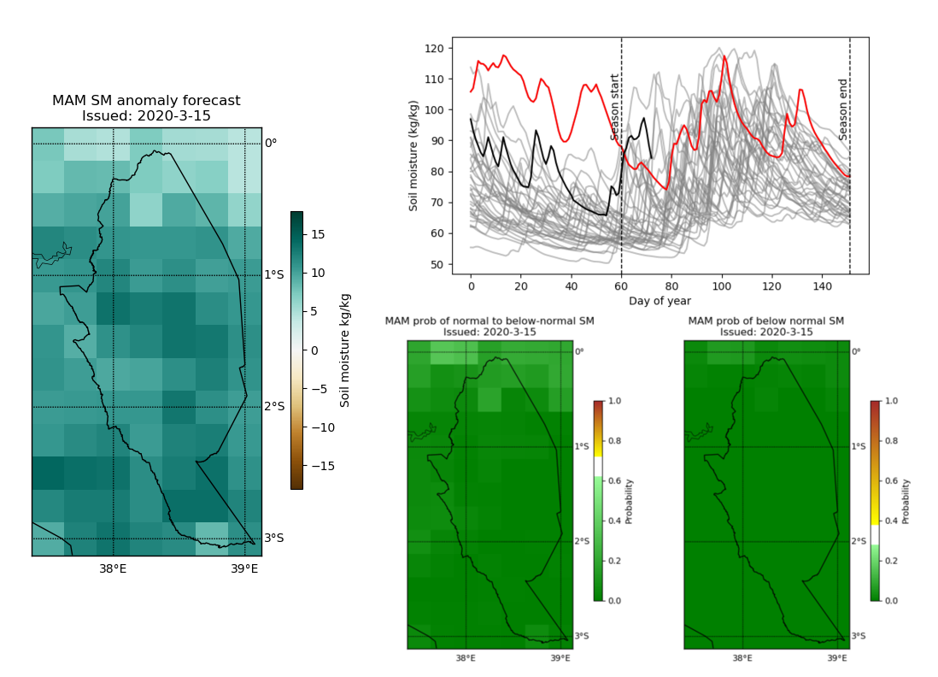Given the early stage in the season, there remains much uncertainty in the forecast. Whilst the probability of normal (<67th percentile) or below normal (<33rd percentile) soil moisture conditions are low at this stage, it is too early to tell whether Kitui will experience drought conditions this MAM season.



ForPAc is funded through by NERC and DFID through the ‘Science for Humanitarian Emergencies and Resilience’ (SHEAR) Research Programme. Grant number NE/P000673/1c. In partnership with:

**Figures:**

1. Forecast MAM soil moisture anomaly.
2. 2020 soil moisture (black line) compared to historic years 1983-2019 (grey lines). Red line = 1998 following heavy 1997 OND rains.
3. Probability of normal or below normal (<67th percentile) MAM soil moisture.
4. Probability of below normal (<33rd percentile) MAM soil moisture.

**A**

**B**

**C**

**D**